Year 10 Science
Semester 1 Examination 2105 - Revision

Astronomy

1. Complete the following table.

TERM | DEFINITION
light year
constellation
galaxy
nebula
supernova
red giant
black hole
sunspot
corona
fusion

2. Light travels at 300,000 km/sec. A star is 97.6 light years away. We can only travel at about 15 - 20 km/second with our best rockets.

(a) With our current technology, are we likely to be able to travel to this star in the near future? Give a few reasons for your answer.

YES / NO (Circle your answer.)

Reasons: •

•

•

(b) Calculate how long it will take to get to this star (in seconds).
sp
d
t

3. (a) What is the major element found in the Sun?

(b) What happens to this element so that the Sun produces its energy?

(c) The Sun loses 5 million tonnes of mass per second. According to Einstein's equation (E = mc²), waht does this mass become?

4. How is the surface temperature of a star related to its colour?

TEMPERATURE | COLOUR
 | blue
 | red
 | yellow

5. (a) About how old is our Sun (in millions of years)? million years

(b) How much longer will it "live"? million years

6. (a) Draw a flow diagram (with arrows) to show the stages of our Sun's remaining life as it runs out of fuel.

Sun

(b) Do similar flow diagrams for the following types of stars.

Huge star

Giant star

(c) The difference between a nova and a supernova is the size of the explosion that takes place. What happens to a star to cause it to explode?

7. (a) Describe the size of the gravity near a black hole.

(b) Why does a black hole appear black?

8. Complete the following matrix to compare the Big Bang and Steady State Theories, using ticks to show which statements apply to one, both or neither theory.

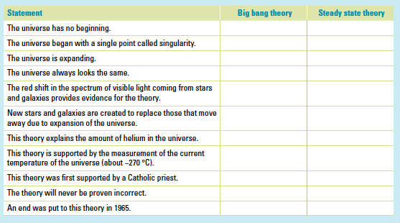

9. Why are the constellations we see now so different from the way they were many centuries ago?

10. How have scientists gained their knowledge of the life and death of stars if the processes involved take millions of years to occur?

11. What is the difference between a neutron star and a black hole?

12. What makes stars group together to form galaxies?

13. The Doppler effect is most commonly associated with the changing pitch of a sound as its source moves past you. For example, the pitch of the noise made by a speeding train increases as it approaches you and decreases as it moves away from you. Explain how the Doppler effect is relevant to the study of the universe.

14. What is cosmic microwave background radiation and why does it exist?

